**Electrically Tunable Exchange Bias**

Peyton Murray1, Junwei Zhang2, Xixiang Zhang2, Kai Liu1,3*

*1Physics Department, University of California, Davis, CA 95616, USA*

*2King Abdullah University of Science & Technology, Thuwal 23955-6900, Kingdom of Saudi Arabia*

*3Physics Department, Georgetown University, Washington, DC 20057, USA*

*Corresponding author: Kai.Liu@georgetown.edu

**Abstract**

Electrically induced ionic motion offers a new way to realize voltage-controlled magnetism, opening the door to a new generation of logic, sensor, and data storage technologies. Here, we demonstrate a two-step approach towards magnetoionic control of exchange bias. First, a Gd capping layer is deposited onto thin film antiferromagnetic Ni0.5Co0.5O, initiating a solid-state redox reaction which reduces the oxide to ferromagnetic NiCo in a thin interfacial region. Upon field cooling, the hysteresis loop becomes exchange biased, demonstrating interfacial coupling between the NiCo and the remaining oxide. Second, an electric field is applied perpendicular to the interface, driving O2- ions toward the Gd layer. Subsequent magnetometry reveals an increase in the exchange bias by ~15%, while electron microscopy directly images ion-migration-induced chemical segregation and microstructural disorder. While these effects do not appear to be electrically reversible in this system, thermal cycling resets the exchange bias back to its field-cooled value. These results highlight the viability of this approach for controlling interfacial magnetic properties, and suggest new routes toward systems with improved magnetoionic performance.

Methods aiming to control magnetism using electric fields have attracted significant interest in recent years with the promise of enabling a new generation of nonvolatile, low-dissipation electronics. While prevailing semiconductor-based logic and memory technologies rely on electric currents and are therefore subject to energy losses due to joule heating, electric field-based approaches in principle have no such limitation. Recent research has shown ionic migration to be a powerful tool for modifying the magnetic properties of metallic and oxide ferromagnets. For example, several experiments have demonstrated reversible control of interfacial anisotropy in Pt/GdOx/Co trilayers1–4. In these trilayer systems, oxygen ions in the GdOx layer are mobile and move under an externally applied electric field. A correctly oriented field can therefore drive oxygen towards the Co interface and initiate an oxidation reaction, altering the Co-O coordination, which in turn affects the anisotropy. Remarkably the effect is reported to be at least partially reversible, with reverse bias acting to reduce the Co interface back to a metallic state. Meanwhile, Grutter *et al.* succeeded in using chemically-induced ion migration to modify oxygen stoichiometry in a thin film La0.7Sr0.3MnO3/Gd bilayer5. Their approach, motivated by the apparently high oxygen mobility of GdOx and high oxygen affinity of metallic Gd, involves depositing a thin capping layer of Gd at room temperature onto the oxide. The Gd deposition initiates a solid-state redox reaction with the neighboring oxide at the interface which lowers the valence state of the Mn ions, with dramatic consequences for the magnetism, structure, and transport properties. Meanwhile, Gilbert *et al.* relied on the same chemical mechanism to modify the magnetic reversal behavior of an exchange biased NiCoO/GdFe system6. Since exchange bias is extremely sensitive to changes in interfacial chemistry and morphology7–10, the effect is a delicate probe of magnetoionic activity.

Here, we present a new approach for electrically tuning exchange bias in a thin film Ni0.5Co0.5O/Gd bilayer system. Harnessing the extreme oxygen reactivity of metallic Gd, a sputtered capping layer of Gd strips away oxygen from an adjacent antiferromagnetic (AF) Ni0.5Co0.5O (NiCoO) layer, reducing only the oxide near the interface to ferromagnetic (FM) NiCo alloy. This interfacial layer is magnetically coupled to pinned uncompensated moments in the remaining AF oxide. Upon field cooling magnetometry reveals the magnetic hysteresis loop to be exchange biased, confirming the AF/FM coupling. Furthermore, after applying and removing an electric field perpendicular to the interface, an enhancement of the exchange bias by ~15% is observed. Electron microscopy images of the NiCoO/Gd interface show disruption to the microstructure, likely due to electric-field-induced ionic motion. Although reverse biasing the interface has no effect on the magnetic reversal behavior, further thermal cycling resets the major loop back to the field cooled state, indicating that these magnetoionic effects may be at least partially reversible. Our results demonstrate the viability of this approach for tuning interfacial magnetism through ionic motion, and highlight a new pathway towards nonvolatile and energy efficient magnetic switching devices.

The layer structure of the samples studied was Si (substrate, naturally oxidized)/Ta (1 nm)/Pt (10 nm)/Al2O3 (170 nm)/Ni0.5Co0.5O (20 nm)/Gd (20 nm)/Pt (10 nm), with Pt layers functioning as electrodes for the application of an electric field and Al2O3 as a conduction barrier (**Fig. 1a**). Films were fabricated at room temperature via sputtering and patterned using standard photolithographic processing and lift-off techniques to allow access to the bottom electrode after fabrication. Magnetometry measurements were carried out on two identically-prepared films (samples A and B) in the as-grown state, again after a field cooling, and once again after undergoing a voltage-conditioning procedure. Afterward, sample A was measured after a reverse-bias voltage-conditioning procedure, while sample B was measured after field-cooling a second time. Room temperature magnetometry of the as-grown states in both samples show a nonzero ferromagnetic moment (**Fig. 1b, d**), even though none of the constituent materials exhibit ferromagnetism at this temperature (Gd 11. Only NiCoO contains magnetic elements, indicating a partial reduction of NiCoO has occurred to form metallic NiCo (**Fig. 1a inset**). Upon heating above the NiCoO Neél temperature (12,13 to 420 K and cooling back to room temperature in a 10 kOe magnetic field, the major loop becomes biased and the coercivity increases. Both of these effects are expected for an exchange biased system7–10, again suggesting the formation of a ferromagnetic NiCo layer adjacent to the antiferromagnetic NiCoO. The emergence of a magnetic moment is also consistent with previous work on a similar system, where a magnetic signal originating from Ni and Co moments at the interface of a NiCoO/GdFe bilayer was directly observed via x-ray spectroscopy and polarized neutron reflectometry6.

In sample A, the effects of electric-field-induced ionic motion on the magnetic behavior of the interfacial NiCo layer were investigated by applying an electric field of 0.5 MV/cm in the direction from the Gd toward the NiCoO at room temperature for 12 hours. In this orientation, O2- ions in the NiCoO layer are expected to drift toward Gd, while metal ions (Ni2+ and Co2+) are expected to drift in the opposite direction. Magnetometry of the resulting voltage-conditioned sample shows both an enhancement in coercivity as well as bias (ΔHc = 16 Oe, ΔHb = –31 Oe) (**Fig. 1c**) as compared to the field cooled state, indicative of interfacial magnetoionic activity. Subsequent voltage conditioning under a reverse bias at room temperature had no significant effect on the hysteretic behavior of the interfacial layer, demonstrating a degree of irreversibility. Although reverse-biasing had no effect on the behavior of the interfacial magnetic layer at room temperature, ionic diffusion is known to be enhanced at elevated temperatures14. To examine the thermal stability of the voltage-conditioned state, sample B was prepared similarly to sample A: field cooling gave rise to exchange bias (**Fig. 1d**), and voltage conditioning again resulted in an enhancement in the coercivity and bias (ΔHc = 9 Oe, ΔHb = –25 Oe). Finally, a second field cooling procedure was carried out from 420 K to room temperature in a 10 kOe field. Subsequent magnetometry shows the major loop returning from the voltage-conditioned state back to the original field cooled state (**Fig. 1e**).

To further understand the evolution of the interfacial ferromagnetic layer after field cooling and voltage conditioning, high resolution scanning transmission electron microscopy (STEM) was carried out on three additional samples prepared in the as-grown (AG), field cooled (FC), and field cooled+voltage conditioned (FCVC) states. Representative images of the NiCoO/Gd interface, show each layer to be polycrystalline in the as grown state (**Fig. 2a**), with an abrupt boundary between the two materials. After field cooling only a few crystal planes are visible; as thermal treatment often improves crystallinity15, this amorphization is likely the result of ionic migration, enhanced by the elevated temperature reached during field cooling (**Fig. 2b**). After voltage conditioning (**Fig. 2c**) the region near the interface remains largely amorphous and the interface becomes less abrupt. While NiCoO grains are visible in the AG and FC state, none are visible in the FCVC state. Since ionic diffusion is expected to be enhanced at grain boundaries14,18, the disruption of the NiCoO grains is likely a contributing factor to irreversibility of the voltage-conditioning effects under reverse bias. In addition to microscopy, elemental distributions were mapped across the NiCoO/Gd interface via electron energy loss spectroscopy (EELS) (**Fig. 2d-f**); in the field-cooled sample, the oxygen concentration goes to zero well before the interface, directly confirming the presence of the interfacial FM. Interestingly, a clear segregation between Ni and Co atomic distributions occurs near the Gd interface, indicating that metal ions participate in ionic migration. This segregation can be explained by the generally lower enthalpies of formation of Gd-Ni compounds, which are energetically favored over Gd-Co alloys16,17. As oxygen leaching process leaves behind metallic Ni and Co, Gd-Ni alloys preferentially form, causing the Co distribution to be pushed deeper into the remaining NiCoO. EELS analysis shows further segregation between the Ni and Co elemental distributions after voltage conditioning.

The magnetic behavior of the NiCoO/Gd system is the result of two separate ion migration mechanisms. The first mechanism occurs during deposition of the Gd layer, which results in a chemically-induced redox reaction that strips oxygen from the adjacent NiCoO, leaving behind the ferromagnetic layer of NiCo observed via magnetometry. The gadolinium oxidation process is energetic; taking the enthalpy of formation of NiO and CoO to be the same ((Ni, Co) + O $→$ ΔH = –2.5 eV), the reaction is exothermic, producing (3(Ni, Co)O + 2Gd $→$ 3(Ni, Co) + Gd2O3) ΔH = –11.4 eV of heat per molecule of Gd2O3 formed19. Thus, local heating may increase ionic mobility in the surrounding region, although the degree to which this feedback effect drives the redox reaction is difficult to quantify due to the inhomogeneity of the interface. While the magnetic moment observed in magnetometry corresponds to a layer thickness of only ~1.5 Å assuming equal Ni and Co concentration, the amorphous region formed near to the NiCoO/Gd interface is actually much wider due to the disruption of the nearby Gd and NiCoO by the redox reaction (**Fig. 2a**). The magnetization of this structurally disordered region is likely to be lower than expected for a binary alloy, owing to residual oxygen and differences in atomic coordination as compared to the crystalline phase. As this system is field cooled, the enhanced ionic mobility combined with the chemical potential gradient provided by the Gd interface induces further oxygen migration, disrupting an even larger region near the interface. The resulting amorphization of the interface is observed in the STEM image of the FC sample. After field cooling, the hysteresis loop is exchange biased by the coupling between the interfacial FM NiCo and the remaining AF NiCoO.

The second ionic migration mechanism, electric-field-induced motion, occurs as a result of voltage conditioning. During voltage conditioning, the interfacial NiCo becomes further enriched with Ni via the alloying-enthalpy mechanism discussed previously. As the ratio of Ni (*Ms* = 495 emu/cm3) to Co (*Ms* = 1400 emu/cm3) increases, the remaining interfacial FM layer has a reduced magnetization compared to the field-cooled state. According to Malozemoff’s random field model20, the observed exchange bias is inversely proportional to the saturation magnetization of the interfacial ferromagnet:

$$H_{b}=\frac{2z\sqrt{AK}}{π^{2}M_{s}t}$$

where *A* and *K* are the AF layer exchange stiffness and anisotropy, *Ms* and *t* are the FM layer saturation magnetization and thickness, and *z* is a number of order unity which depends on the shape of AF domains. As the interfacial FM magnetization decreases due to the ionic migration of Co, the bias increases accordingly. Additionally, the STEM images show that the electric-field-induced ionic motion disrupts the grain boundaries of the Gd and NiCoO; since ion mobility is expected to be highest here, disruption to these pathways renders the ionic distributions immobile and leads to the irreversibility under reverse bias. By contrast, a second field cooling procedure resets the bias to its original value. Since bulk ionic diffusivity is enhanced at elevated temperature, grain boundaries play less of a role in ionic migration during thermal treatment, allowing the interface to recover to a pre-voltage-conditioned state.

In summary, the unusual magnetic behavior of the NiCoO/Gd system has been discussed. The formation of a ferromagnetic NiCo layer near the interface as a result of Gd-driven, redox-induced ionic migration has been established via magnetometry and electron microscopy. Field cooling behavior typical of exchange biased FM/AF systems was observed, with the interfacial NiCo coupling to the remaining oxide. Importantly, the exchange bias in this system can be enhanced by up to 15% under a voltage-conditioning procedure, an effect which can be qualitatively explained by chemical segregation and Ni enrichment of the interfacial FM layer. Finally, this effect was found to be reversible under thermal cycling but not under reverse biasing, due to ionic-migration-induced disruption of grain boundaries near the interface, which comprise the most effective ionic pathways. These results demonstrate a new magnetoionic approach for controlling exchange bias, with greater switching speed and larger changes to the bias likely possible under further material optimization and improved fabrication processes.

**Acknowledgements:** We thank Professor Yayoi Takamura from UC Davis for enlightening discussions.

**Funding:**

**Author contributions:** P. D. M. fabricated the samples, carried out magnetic measurements, and wrote the manuscript. J. Z. took TEM images. X. Z. and K. L supervised the experiments and advised the project. **Competing interests:** The authors declare no competing interests. **Data and materials availability:** Experimental data is available upon request.

**Figures**

**Figure 1.** Layer structure of the samples **(a)**, and close up showing interfacial NiCo which forms immediately upon Gd deposition (inset). Major loops of sample A in the as-grown (AG) and field cooled (FC) states **(b)**. Major loops of sample A after field cooling (FC), positive voltage conditioning (FC+VC), and after reverse bias voltage conditioning (FC-VC) **(c)**. Major loops of sample B in the as-grown (AG) and field cooled (FC) states **(d)**. Major loops of sample A after field cooling (FC), positive voltage conditioning (FCVC), and after a second field cooling procedure (FCVCFC) **(e)**.

**Figure 2.** STEM images of the Gd/NiCoO interface for the as-grown **(a)**, field cooled **(b)**, and voltage conditioned samples **(c)**. EELS elemental distributions measured across the Gd/NiCoO interface for the as-grown **(d)**, field cooled **(e)**, and voltage conditioned samples **(f)**. The *z*-coordinate runs perpendicular to the interface.



**Figure 1**

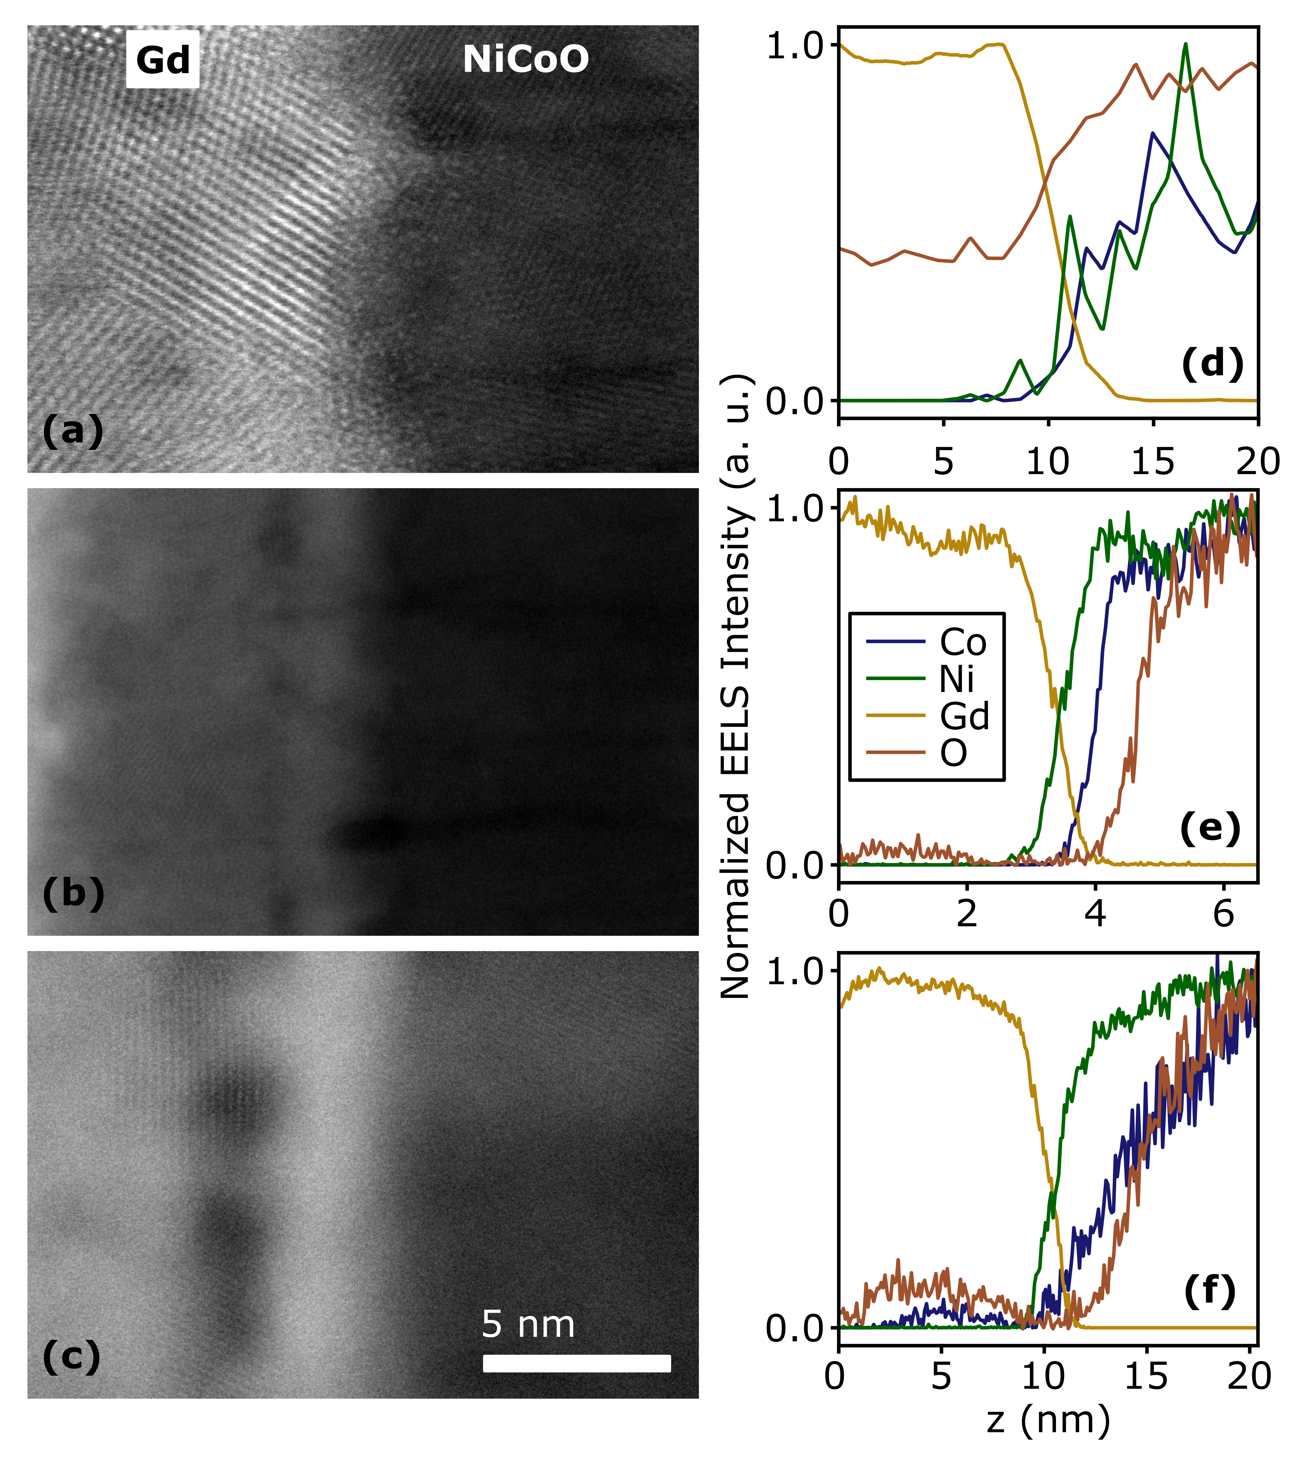

**Figure 2**

**References**

1. Bauer, U. *et al.* Magneto-ionic control of interfacial magnetism. *Nat. Mater.* **14,** 174–181 (2015).

2. Bi, C. *et al.* Reversible control of Co magnetism by voltage-induced oxidation. *Phys. Rev. Lett.* **113,** 267202 (2014).

3. Bauer, U., Emori, S. & Beach, G. S. D. Voltage-controlled domain wall traps in ferromagnetic nanowires. *Nat. Nanotechnol.* **8,** 411–416 (2013).

4. Gilbert, D. A. *et al.* Structural and magnetic depth profiles of magneto-ionic heterostructures beyond the interface limit. *Nat. Commun.* **7,** 12264 (2016).

5. Grutter, A. J. *et al.* Reversible control of magnetism in La0.67Sr0.33MnO3 through chemically-induced oxygen migration. *Appl. Phys. Lett.* **108,** 082405 (2016).

6. Gilbert, D. A. *et al.* Controllable positive exchange bias via redox-driven oxygen migration. *Nat. Commun.* **7,** 11050 (2016).

7. Nogués, J. & Schuller, I. K. Exchange bias. *J. Magn. Magn. Mater.* **192,** 203–232 (1999).

8. Kiwi, M. Exchange bias theory. *J. Magn. Magn. Mater.* **234,** 584–595 (2001).

9. Ohldag, H. *et al.* Correlation between Exchange Bias and Pinned Interfacial Spins. *Phys. Rev. Lett.* **91,** 2–5 (2003).

10. Berkowitz, A. E. & Takano, K. Exchange anisotropy — a review. *J. Magn. Magn. Mater.* **200,** 552–570 (1999).

11. Kittel, C. *Introduction to Solid State Physics*. (John Wiley & Sons, Inc, 2005).

12. Ambrose, T., Liu, K. & Chien, C. L. Doubly exchange-biased NiCoO/NiFe/Cu/NiFe/NiCoO spin valves. *J. Appl. Phys.* **85,** 6124–6126 (1999).

13. Yang, D. Z. *et al.* Positive exchange biasing in GdFe/NiCoO bilayers with antiferromagnetic coupling. *Phys. Rev. B - Condens. Matter Mater. Phys.* **71,** 144417 (2005).

14. Balluffi, R. W., Allen, S. M. & Carter, W. C. *Kinetics of Materials*. (A. John Wiley & Sons, 2005).

15. Hotovy, I., Liday, J., Spiess, L., Sitter, H. & Vogrincic, P. Study of Annealed NiO Thin Films Sputtered on Unheated Substrate. *Japanese J. Appl. Physics, Part 2 Lett.* **42,** (2003).

16. Colinet, C., Pasturel, A. & Buschow, K. H. J. Study of the Enthalpies of Formation in the Gd-Ni System. *Metall. Trans. A* **17A,** (1986).

17. Colinet, C., Pasturel, A. & Buschow, K. H. J. Study of the enthalpies of formation in the Gd-(Fe, Co, Pd, Pt) systems. *Metall. Trans. A* **18,** 903–907 (1987).

18. Kim, Y. M. *et al.* Probing oxygen vacancy concentration and homogeneity in solid-oxide fuel-cell cathode materials on the subunit-cell level. *Nat. Mater.* **11,** 888–894 (2012).

19. Dean, J. A. *Lange’s Handbook of Chemistry*. (McGraw-Hill, 1999).

20. Malozemoff, A. P. Random-field model of exchange anisotropy at rough ferromagnetic- antiferromagnetic interfaces. *Phys. Rev. B* **35,** 3679–3682 (1987).